Cloning a repository from Github to your local machine

1. Create a folder on your computer where you want the project repository to reside
2. Use gitbash to locate the folder you just created on your directory
   1. 
3. Use git clone command to clone the repository to your computer
   1. 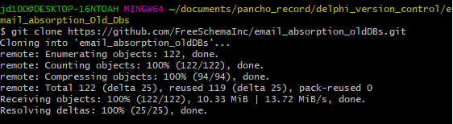
4. All files should be in the folder now
   1. 